Project Title – Air Quality monitoring using IOT

Process to Bulit: 421221106014

* Choose the Sensors: Select the appropriate sensors to measure air pollutants like PM2.5, CO2, CO, O3, NO2, etc.
* Connect the Sensors: Connect the sensors to a microcontroller board like Arduino or Raspberry Pi to collect data.
* Set up IoT Connectivity: Use an IoT module like ESP8266 or ESP32 to enable wireless connectivity.
* Data Processing: Program the microcontroller to process the sensor data and convert it into meaningful information.
* Connect to the Internet: Use Wi-Fi or Ethernet to connect the system to the internet for remote monitoring.
* Data Transmission: Send the processed data to a cloud platform or a server for storage and analysis.
* Data Visualization: Create a user-friendly interface to display real-time air quality readings and trends.
* Alerts and Notifications: Set up alerts and notifications to inform users about poor air quality conditions.
* Data Analysis: Use data analytics tools to analyze the collected data and identify patterns or trends.
* Continuous Monitoring and Maintenance: Regularly monitor the system's performance, calibrate the sensors if necessary, and ensure proper functioning.

Sensors:

Temperature:

A temperature sensor is a device that measures the temperature of its surroundings. It can be used in various applications, such as weather monitoring, HVAC systems, food storage, and industrial processes. The sensor detects changes in temperature and provides an output signal that can be used to display or control temperature. It's a handy tool for keeping track of the temperature in different environments

Gas Sensor:

A gas sensor is a device that detects the presence and concentration of gases in the surrounding environment. It can be used to monitor and detect various types of gases, such as carbon monoxide, methane, hydrogen, and more. Gas sensors are commonly used in industries, homes, and laboratories to ensure safety and prevent potential hazards. They play a crucial role in detecting leaks, monitoring air quality, and maintaining a safe environment.

Sensors :

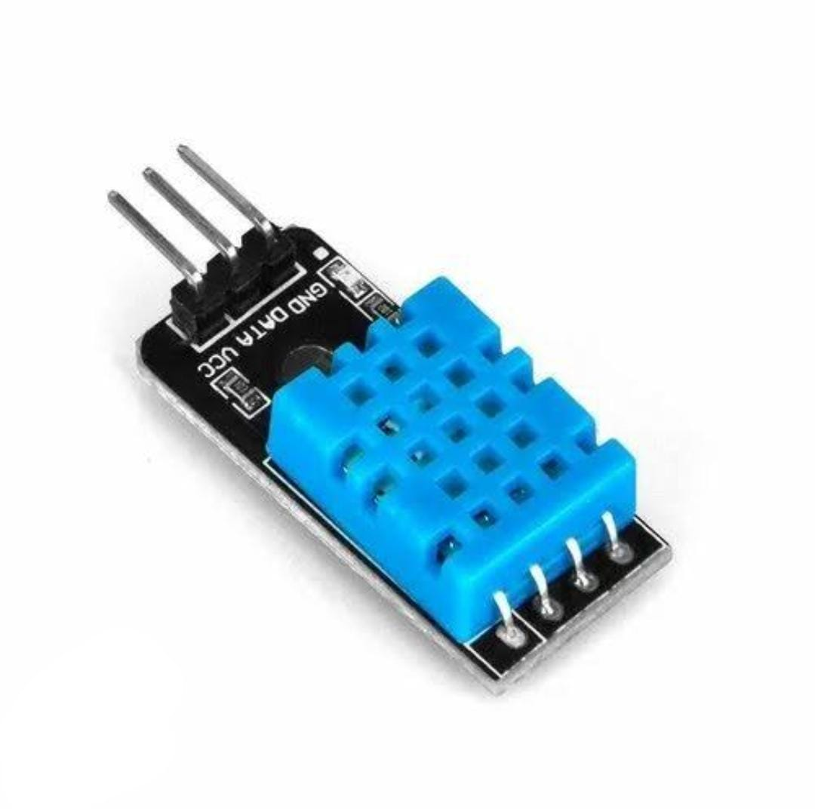

Temperature Sensor

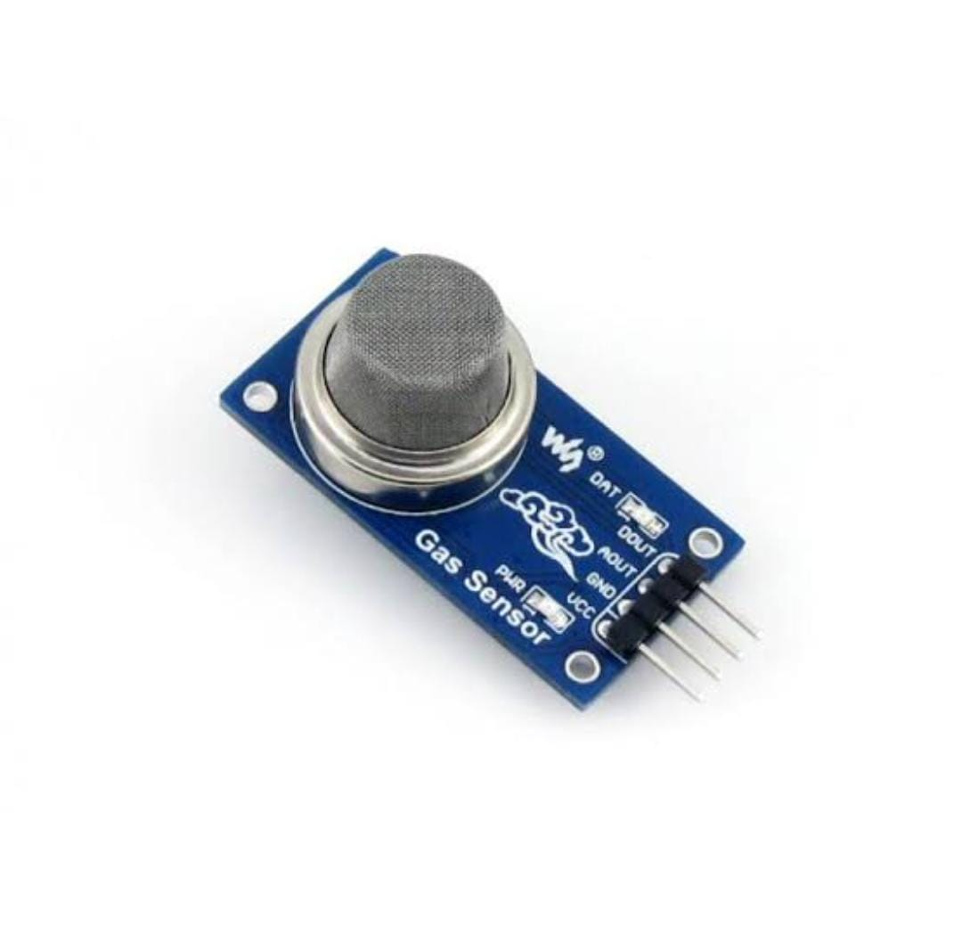

Gas Sensor

Circuit Diagram:

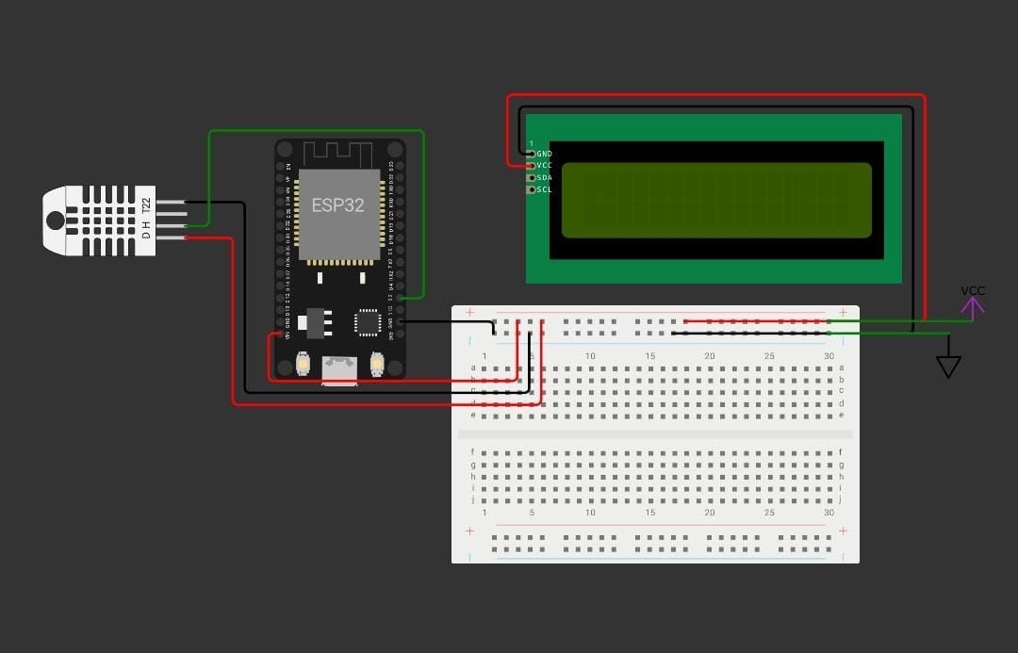

Applications:

Air quality monitoring is important for several reasons. It helps us understand the level of pollutants in the air, which can have a significant impact on our health. It also allows us to identify sources of pollution and take necessary actions to reduce them. Additionally, air quality monitoring helps in assessing the effectiveness of pollution control measures and implementing policies to improve air quality. It's a crucial tool in protecting the environment and ensuring the well-being of communities